**ORDERING AND INVENTORY MONITORING APPLICATION**

In Partial Fulfillment

of the Requirements for the Degree

Bachelor of Science in Information Technology

By

Reynan Jhay A. Busano

Eljay Ralden C. Secuya

**April 2024**

**CHAPTER 1**

**THE RATIONALE**

**Introduction**

In today's fast-paced and competitive business landscape, the effective management of orders, inventory, sales, and customer interactions is crucial for success. A study by (Alifadillah & Supriatna, 2023) found that small-scale cafes, similar to Alters Café, often struggle with manual order taking and inventory monitoring, leading to inefficiencies and errors in operations. Additionally, MenuKu: An Android-based Solution to Food and Beverage Order Management developed by (Pratama et al., 2023) showcases the potential of digital solutions in enhancing order processing and improving customer service in the foodservice industry. These findings underscore the relevance and importance of developing a tailored digital solution, such as the proposed Ordering and Inventory Monitoring Application, to address the specific challenges faced by small-scale establishments and enhance their operational efficiency.

Research conducted by (Andrii & National, 2022) emphasizes the growing importance of digital systems in the hospitality sector, highlighting their role in streamlining operations and enhancing customer satisfaction. A study by (Juan-Gabriel & Martínez-Navalón, 2021) further underscores the impact of digital technology on improving inventory management and order processing in small-scale restaurants. Despite this, there remains a notable research gap in understanding the specific needs and preferences of small-scale establishments like Alters Café regarding digital solutions for order and inventory management. This study aims to address this gap by exploring the challenges faced by such establishments and proposing a tailored digital solution to improve efficiency and customer engagement.

In response to the identified challenges, we propose the development of an "Ordering and Inventory Monitoring Application" tailored to the unique needs of small-scale cafes like Alters Café. This solution aims to automate order processing, simplify inventory monitoring, and enhance customer communication, aligning with the preferences expressed by Ms. Teneza and similar stakeholders. By providing a user-friendly interface, comprehensive training and support, and robust data security measures, the proposed application seeks to empower small-scale establishments to overcome their operational hurdles and thrive in an increasingly digital landscape.

Through this research, we seek to address the immediate needs of Alters Café and also contribute to the broader conversation on digital innovation in the hospitality and food-service industry. By understanding the specific challenges faced by small-scale establishments and offering tailored solutions, we aim to drive operational efficiency, improve customer satisfaction, and pave the way for sustainable growth in this dynamic sector.

**Statement of the problem**

Through our survey research, we discovered that Alters Café encounter significant challenges in managing their operations manually. These challenges include:

* Limited visibility into inventory levels
* Difficulty in tracking sales data
* Inefficient order management processes

**Objectives of the Study**

Our study aims to address the challenges faced by Alters Café through the development of a digital solution “Ordering and Inventory Monitoring Application. Specifically, we seek to:

* To gather data on the specific needs and preferences of Alters Cafe, regarding digital solutions for order and inventory management through a survey.
* To analyze the gathered data to identify common challenges and requirements faced by Alters Café.
* To design the functionalities of the system, named the Ordering and Inventory Monitoring Application, to address the identified challenges and requirements at Alters Cafe, by enabling efficient order management, where staff can input and manage customer orders, and by providing real-time monitoring of inventory levels
* To develop the Ordering and Inventory Monitoring Application based on the designed specifications.
* To test the functionality and usability of the Ordering and Inventory Monitoring Application in an IDE.
* To implement the finalized version of the Ordering and Inventory Monitoring Application in Alters Café.

**Scope and Limitations**

The following are the scope and limitations of the development of Ordering and Inventory Monitoring Application, with a specific focus on addressing the needs of Alters Cafe.

**Scope:**

* The application will primarily concentrate on these key aspects: efficient order processing, simplifying inventory monitoring, and sales data tracking.
* Prioritizing functionalities related to ordering and inventory monitoring, ensuring these features are robust and tailored to the unique requirements of Alters Cafe

**Limitations:**

* Full sales data analytics
* The inventory management system for individual ingredients such as beans, lemon, and ice allows for functionalities like adding, deleting, and updating stocks. However, it does not automatically subtract ingredients when a coffee is sold. This limitation may affect the real-time accuracy of ingredient stock levels and require manual adjustment to reflect sales.

**Significance of the Study**

This study holds significant importance as it directly addresses the pressing need for digital solutions within the hospitality and food service industry.

* For Alters Cafe: The proposed Ordering and Inventory Monitoring Application offers a tailored solution to streamline key operations, such as order processing and inventory monitoring, addressing challenges faced by the cafe and improving its overall efficiency and competitiveness.
* For Customers: The application aims to enhance the customer experience through streamlined ordering processes which will improve customer interaction, leading to a more satisfying experience at Alters Cafe.
* For NBSC: This project serves as a practical application of classroom learning, providing students with valuable hands-on experience in software development and project management. It also lays the groundwork for future capstone projects and research endeavors within the school.
* For Staff: The application will empower cafe staff to efficiently manage orders and monitor inventory, reducing manual workload and enhancing customer service.
* For Researchers: This project serves as a stepping stone for students' academic and professional development, offering insights into real-world problem-solving and software development processes. It also provides a foundation for future research and innovation.
* For Future Researchers: The findings and outcomes of this study can serve as valuable reference points for future research endeavors in the field of digital solutions for small-scale cafes and the broader hospitality industry.

**CHAPTER 2**

**REVIEW OF RELATED LITERATURE**

In this chapter, relevant studies conducted in the field of technological innovation, digital marketing, and customer satisfaction in the hospitality and food service industry will be reviewed. These studies offer valuable insights into the current state of research and help identify gaps that the upcoming study aims to address.

**Local studies**

According to Castillo-Vergara et al. (2021) and Macailao (2023), technological innovation and the adoption of digital solutions play pivotal roles in enhancing efficiency within the food industry. Castillo-Vergara's bibliometric analysis underscores the significance of technological advancements, while Macailao's study on electronic payment platforms highlights the ease of use and acceptance of digital solutions. Both studies emphasize the relevance of tailored digital innovations to address specific challenges, thus supporting the rationale for embracing digitalization within the food service sector.

According to Mia et al. (2024) and Sebastian Chavez et al. (2021), digital technology adoption and effective marketing strategies are vital for the sustainability and growth of food-related businesses. Mia's investigation into digital technology adoption among MSMEs identifies key enablers and barriers, emphasizing the importance of post-pandemic resilience. Similarly, the evaluation of digital marketing strategies underscores the significance of social media, SEO, and content marketing in enhancing brand awareness and sales. Together, these studies highlight the essential role of digitalization in navigating challenges and seizing opportunities within the food industry.

According to Castillo et al. (2020) and Bahillo (2022), the implementation of digital solutions is instrumental in optimizing operational processes and future-proofing food service operations. Castillo et al.'s research on automated drive-through ordering systems showcases the potential of digital solutions in reducing processing time and enhancing order accuracy. Bahillo's documentation of food service experiences during the pandemic emphasizes the importance of adopting digital platforms to cater to evolving consumer needs. Both studies underscore the significance of embracing technological trends to improve efficiency and customer satisfaction.

According to Claudine Sykimte (2023) and Umunna (2021), innovative digital solutions and effective communication strategies are essential for engaging customers and enhancing satisfaction. Claudine Sykimte's exploration of digital innovations in food ordering highlights the benefits of enhanced convenience and data-driven insights, while Umunna's study on social media marketing strategies emphasizes the need for innovative communication channels to maintain customer engagement. Together, these studies underscore the importance of leveraging digital tools to meet evolving consumer expectations and drive business growth.

According to Jenelen (2019) and Margate et al. (2020), self-service technologies and mobile applications offer promising solutions for improving customer satisfaction and operational efficiency in the food service sector. Jenelen's assessment of self-ordering kiosk service systems highlights their positive impact on convenience and efficiency, while Margate et al.'s focus on mobile inventory management systems underscores their benefits in enhancing accuracy and efficiency. Both studies underscore the potential of technology-driven solutions to enhance the overall dining experience and streamline operations within food-related businesses.

**Foreign studies**

In recent times, the hospitality and food service industry has witnessed a significant shift towards digitalization, particularly with the widespread adoption of mobile applications. These applications, commonly referred to as mobile food-ordering apps (MFOAs), have become increasingly popular, especially during the pandemic period. (Cankat, 2021) emphasize the critical role of MFOA satisfaction in enhancing restaurants' brand satisfaction and loyalty, aligning with (Sharma et al., 2023) findings on the significance of mobile apps in improving customer engagement and overall experience. Given the unique challenges faced by small-scale cafes, (Herawati et al., 2023) conducted a community partnership program aimed at strengthening spice coffee small and medium-sized enterprises (SMEs) through digital marketing.

The study revealed that educating and training SMEs on digital marketing led to increased motivation and engagement among partners, resulting in improved social media presence and consumer interest. (R. Islam, 2018) shed light on the changing landscape of the food service industry, highlighting the evolving customer demographics and the need for convenience products, which directly impacts the adoption of digital solutions like MFOAs and online ordering systems. Similarly, (Rodgers, 2019) discusses the strategic implications of innovation in food service technology, emphasizing the importance of technological advancements in improving operational efficiency and customer satisfaction.

In the context of small and medium-sized enterprises (SMEs), (Salih et al., 2023) study on implementing automated inventory management systems underscores the benefits of digital solutions in boosting efficiency and cutting costs, resonating with (Rahman, 2020) research on responsive online food ordering applications with social media integration. These studies emphasize the importance of leveraging digital technologies to streamline operations and enhance customer experiences. Moreover, (Morokhovych & Morokhovych, 2023) highlight the strategic importance of digital technologies in restaurant business development, emphasizing their role in attracting customers, increasing sales, and building trust. (King, 2022) research on digital technology-enabled food safety management systems further underscores the need for comprehensive digital solutions to ensure food safety and regulatory compliance.

According to (Tsiotsou, 2020), their study on social media and customer engagement provides insights into the pivotal role of social media in enhancing customer engagement, satisfaction, and loyalty, aligning with the broader theme of leveraging digital platforms to connect with customers and drive business growth.

**Synthesis**

The reviewed local and foreign studies collectively emphasize the vital role of technological innovation and digital solutions in addressing the challenges faced by small-scale cafes like Alters Cafe, particularly in the context of order and inventory management. Local studies underscore the significance of adopting digital platforms and strategies to enhance operational efficiency, improve customer engagement, and future-proof business operations. For instance, studies highlight the benefits of digital marketing, automated ordering systems, and mobile inventory management applications in streamlining operations and boosting customer satisfaction. Similarly, foreign studies emphasize the strategic importance of digital technologies, such as mobile food-ordering apps (MFOAs) and automated inventory management systems, in enhancing efficiency, cutting costs, and improving customer experiences. These findings collectively underscore the critical need for tailored digital solutions, like the proposed Ordering and Inventory Monitoring Application, to address the unique challenges faced by Alters Cafe and drive sustainable growth in the hospitality and food service industry.

**CHAPTER 3**

**METHODOLOGY**

**3.1 Research Design**

**3.1.1 Type of Research**

In the development of an ordering and inventory monitoring system for Alter’s Café, the research study aims to achieve specific objectives through a collaborative and iterative approach. Which promotes a dynamic and interactive research environment that encourage creativity, innovation, and the production of high-quality research outcomes. It emphasizes the importance of teamwork, adaptability, and continuous learning throughout the research process.

By integrating these approaches, the study aims to gain a deeper understanding of the ordering and inventory monitoring system's requirements and user needs, ensuring alignment with the organization's objectives.

**3.2 Research Design Approach**

In the development of an ordering and inventory monitoring system for Alter’s Café, the research design approach integrates agile methodologies with a focus on incremental progress and continuous improvement. Tasks are segmented into sprints, allowing for regular feedback sessions and retrospectives to drive iterative development (Virginia., 2020). This agile approach emphasizes the creation of a functional system that aligns with the specific goals of Alter’s Cafe, with ordering and inventory monitoring being a key application where agile methodology has proven effective (Maryam et al., 2019).

The collaborative nature of the process, coupled with the integration of developmental and qualitative research methods, ensures that the system is tailored to meet the organization's objectives. By adopting this agile research design approach, the study aims to address identified challenges and enhance operational efficiency for Alter’s Cafe through successful system implementation.

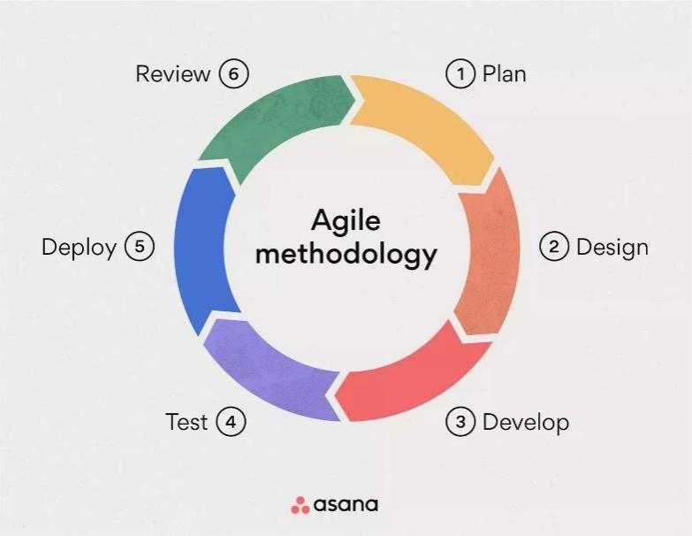

Source: (Anon 2022)

Figure 1. Agile Development

**Requirements Analysis**

In the initial phase of requirements analysis, the researchers sought permission from Alter’s Cafe management to conduct a survey aimed at evaluating their existing monitoring practices. The survey results highlighted a crucial area for enhancement: the ordering and inventory system. In response to this finding, the research team opted to concentrate on creating a tailored ordering and inventory monitoring application for Alter’s Cafe, incorporating features such as receipt printing, order transactions, and sales report.

This study aims to enhance the ordering process at Alter’s Cafe by addressing the lack identified in their current system. Through a thorough understanding of these challenges, the researchers aim to develop a tailored ordering and inventory monitoring application that aligns with the specific requirements and objectives of the business. The decision to embark on this application development underscores the researchers’ dedication to leveraging technology for operational restructuring and enhancing the cafe’s ordering system.



Figure 2. Request Letter

**Planning**

The Gantt chart outlines the timeline for developing the ordering and inventory monitoring application for Alter's Cafe. It provides a visual timeline of the phases, typically displaying tasks along a timeline with start and end dates. Each task is represented as a bar, where the length of the bar indicates the duration of the task.

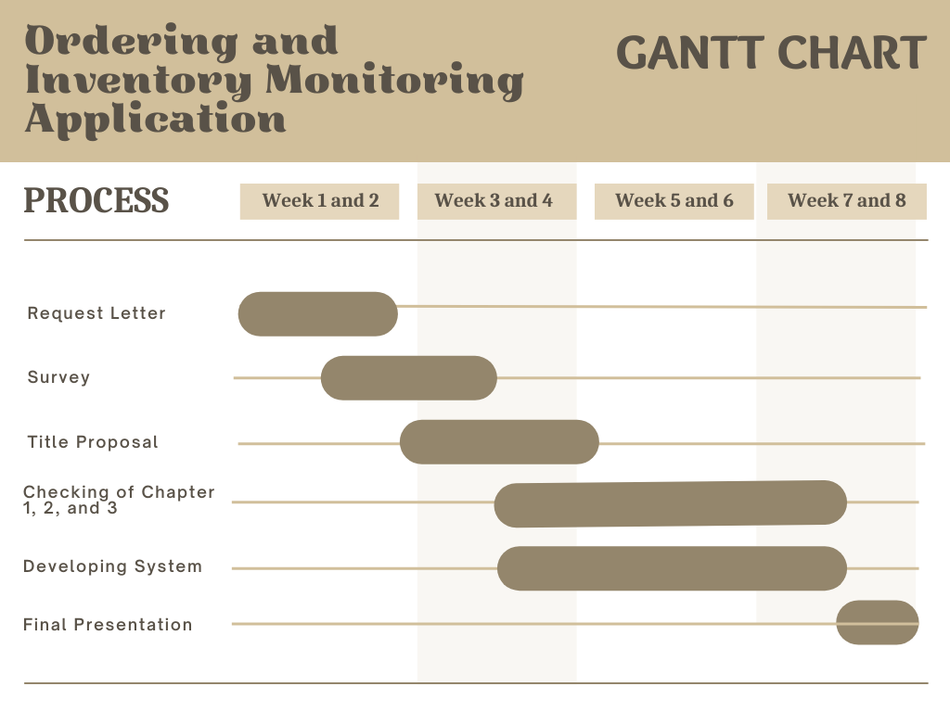This Gantt chart effectively maps out the steps necessary to develop and implement the ordering and inventory monitoring system, ensuring a structured approach to meeting the project's objectives and enhancing operational efficiency for Alter’s Cafe.

Figure 3. Gantt Chart

**Design**

During this stage, the researchers employed Visual Studio Code 2019 to develop the system. Icons were obtained from flaticon.com and utilizing a mix of JavaScript and jQuery for a pleasing presentation.

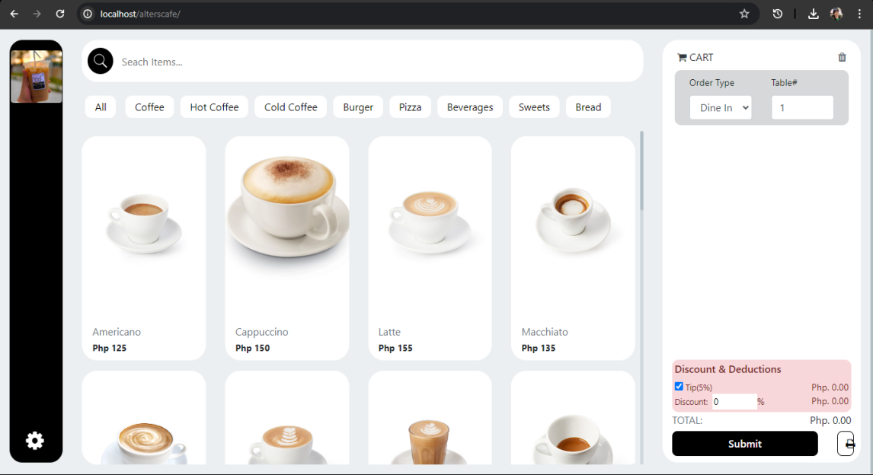Figure 4. GUI

**Implementation, coding or development**

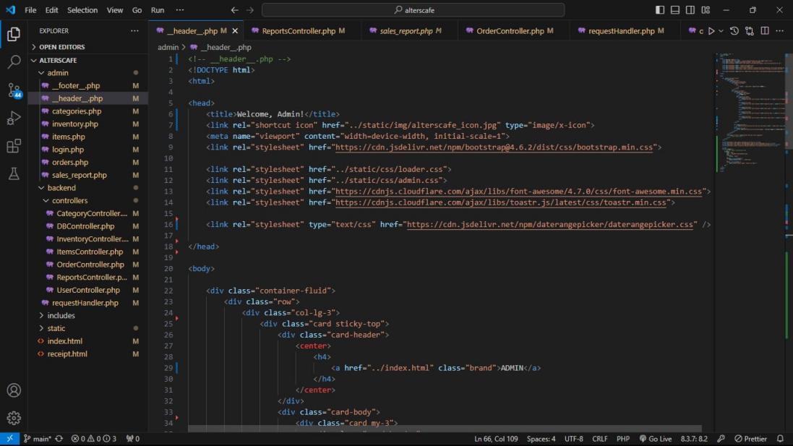In the development stage, the researchers went with Visual Studio Code as their main framework. They used PHP for the backend, Bootstrap for the layout and interface, and supplemented it with JavaScript and jQuery for added functionality. Additionally, they employed MySQL as the database and XAMPP servers.

Figure 5. Source Code

**3.3 System Design Architecture**

This design showcases the overall program flow and system architecture of the system. It provides a visual representation of how the system operates and describes its operational mode.

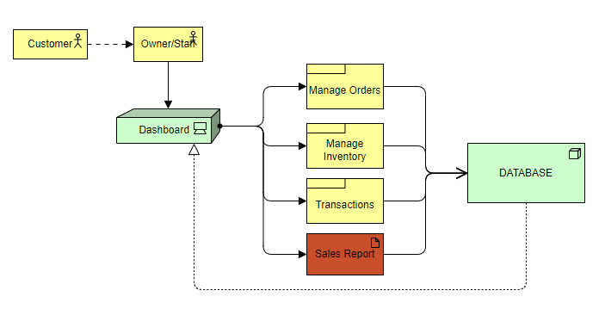

Figure 6. System Architecture

**3.5 System Diagrams**

**Use-Case Diagram**

This diagram shows the different actions that can be performed in the ordering and inventory monitoring system.

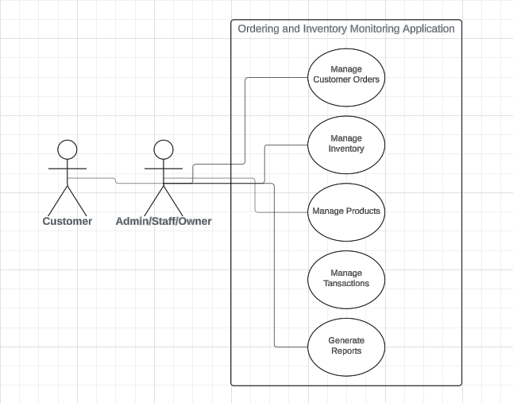

Figure 7. Use Case Diagram

**Entity-Relationship Diagram (ERD)**

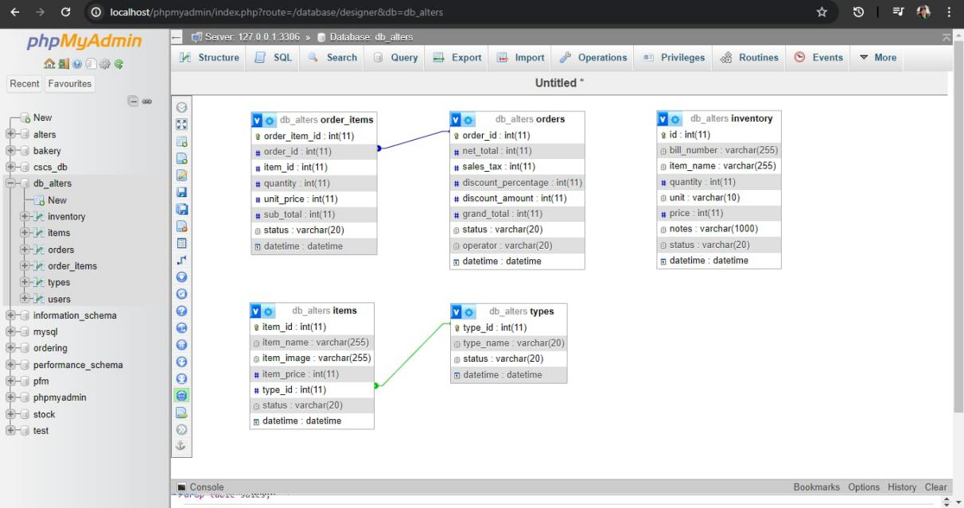This ERD represents a simplified version of the relationships between the entities in the inventory management system for Alter’s Cafe. It consists of five tables: items, order_items, orders, types, and inventory.

Figure 8. Entity Relationship Diagram

**3.6 System Evaluation**

**Deployment**

During the deployment of the ordering and inventory monitoring application for Alter's Cafe, the main goal is to ensure everything works smoothly. This starts with thorough testing to find and fix any problems before using the application. This preparation helps make sure the switch to the new system is as smooth as possible, with minimal disruptions.

Once the system is operational, it is carefully monitored to ensure it performs well. Regular maintenance is done to keep the system updated and working efficiently. Feedback from users is collected to understand how well the system is working and to identify any areas for improvement. The system is designed to grow with the cafe's needs, allowing for new features to be added over time. This ongoing process helps ensure the system continues to meet the cafe's needs and improves its overall efficiency.

**References**

-, P. S., & -, S. B. (2023). Unlocking Customer Engagement: the Power of Mobile Apps in Enhancing Customer Experience. *International Journal For Multidisciplinary Research*, *5*(3), 1–7. https://doi.org/10.36948/ijfmr.2023.v05i03.4103

Ashley, M. N., Margate, C. F., Ravina, M. C., Pido, J. J. G., & Young, M. N. (2020). Seiton: A Mobile Inventory Management System Application for Micro, Small and Medium-sized Enterprise. Doi: 10.1109/ICETAS51660.2020.9484183

Bahillo, E. L. (2022). Documented Experiences among Food Service Businesses towards Future-Proofing the Industry. *JPAIR Multidisciplinary Research*, *49*(1), 17–36. https://doi.org/10.7719/jpair.v49i1.625

Benedict Mia, I., Jimenez, S., Habaradas, R., Jaye Ranieses, J., Javier, C., & Enriquez, J. (2024). Digital Technology Adoption Among Philippine Micro-, Small-,and Medium-Sized Enterprises: Barriers, Enablers & Challenges During COVID-19. *Journal of Business, Ethics and Society*, *4*(1), 0–17. https://doi.org/10.61781/4-1i2024/1bmlm

Cankat, E. (2021). *Journal of Retailing and Consumer Services Role of mobile food-ordering applications in developing restaurants ’ brand satisfaction and loyalty in the pandemic period*. *62*(May). https://doi.org/10.1016/j.jretconser.2021.102608

Castillo-Vergara, M., Quispe-Fuentes, I., & Poblete, J. (2021). Technological innovation in the food industry: A bibliometric analysis. *Engineering Economics*, *32*(3), 197–209. https://doi.org/10.5755/j01.ee.32.3.26000

Castillo, A. M. M., Salonga, L. J. L., Sia, J. A. L., & Young, M. N. (2020). *Improving Fast-Food Restaurants ’ Method of Operation : Automated Drive-Through Ordering System*. 1838–1849.

Claudine Sykimte. (2023). Revolutionizing the Dining Experience: Exploring Digital Innovations in Food Ordering for Enhanced Customer Satisfaction. *International Journal of Advanced Research in Science, Communication and Technology*, 698–703. https://doi.org/10.48175/ijarsct-12358

De los Santos, J. R., Suyom, J. R., Comora, M. B., de los Santos, G. N., de los Santos, M. G., & Aruy, R. C. (2021). Imbentaryo App: An Intelligent Inventory and Decision Support System. Doi: 10.1109/IT51528.2021.9390123

Franklin, W. S., Salazar, M. S., Martínez-García, S., Ureña-Aguirre, J. P., & Altamirano, S. (2023). UAVs for Business Adoptions in Smart City Environments: Inventory Management System. Electronics, 12(9), 2090-2090. Doi: 10.3390/electronics12092090

Herawati, A., Sarwani, S., Listyawati, L., Kamariyah, S., & Widiarto, D. S. (2023). Strengthening spice coffee SMEs based on digital marketing for sustainable business improvement. *Abdimas: Jurnal Pengabdian Masyarakat Universitas Merdeka Malang*, *8*(2), 336–346. https://doi.org/10.26905/abdimas.v8i2.8982

Jenelen, F. (2019). *University of Caloocan City*. *May*, 1960.

King, H. (2022). *Chapter 7 Digital Technology to Enable Food Safety Management Systems*. *July 2020*. https://doi.org/10.1007/978-3-030-44735-9

Kurnaedi, D., Oktora, E., Nasrullah, I., Prayoga, A., & Pramanto, F. A. (2023). Asset and Inventory Data Monitoring Application Design PT. Transmarco. Bit-Tech, 5(3), 174-181. Doi: 10.32877/bt.v5i3.731

Macailao, M. C. (2023). *Assessment of electronic payment platforms adoption and perceived benefits of local coffee shops in poblacion, cauayan city, isabela, philippines*. *May*.

Margate, Ashley & Ravina, Ma & Pido, Jeric & Young, Michael. (2020). Seiton: A Mobile Inventory Management System Application for Micro, Small and Medium-sized Enterprise. 1-5. 10.1109/ICETAS51660.2020.9484183.

Maryam, H., Ali, K., & Sarah, M. (2019). Effective implementation of agile methodologies in inventory management systems. International Journal of Information Systems and Software Engineering, 14(2), 89-105.

Morokhovych, V., & Morokhovych, B. (2023). Digital Technologies as an Important Factor of the Restaurant Business Development. *Restaurant and Hotel Consulting. Innovations*, *6*(1), 27–36. https://doi.org/10.31866/2616-7468.6.1.2023.278469

Noah, A., Ray, K., & Rohel, J. (2021). Mobilizing the streets: the role of food vendors in urban life. Food, Culture, and Society, doi: 10.1080/15528014.2020.1860454

Profile, S. E. E. (2020). *Implementation of Responsive Online Food Ordering Application with Social Media Integration A Project Submitted to University of Derby for the Degree of BSc ( Hons ) in*. *January 2018*. https://doi.org/10.13140/RG.2.2.32716.36486

R. Islam, A. M. and M. H. (2018). This document is discoverable and free to researchers across the globe due to the work of AgEcon Search . Help ensure our sustainability . ａ ｃ ｔ ｏ ｒ ｓＩ ｎ ｆ ｌ ｕ ｅ ｎ ｃ ｉ ｎ ｇＰ ｒ ｉ ｃ ｅｏ ｆＡ ｇ ｒ ｉ ｃ ｕ ｌ ｔ ｕ ｒ ａ ｌＰ ｒ ｏ ｄ ｕ ｃ ｔ ｓ ａ ｎ ｄＳ ｔ ａ ｂ ｉ ｌ ｉ ｔ ｙＣ ｏ ｕ ｎ ｔ ｅ. *AgEcon Search*, 18.

Rodgers, S. (2019). Innovation in food service technology and its strategic role. *International Journal of Hospitality Management*, *26*(4), 899–912. https://doi.org/10.1016/j.ijhm.2006.10.001

Salih, H. S., Ghazi, M., & Aljanabi, M. (2023). Implementing an Automated Inventory Management System for Small and Medium-sized Enterprises. *Iraqi Journal for Computer Science and Mathematics*, *4*(2), 238–244. https://doi.org/10.52866/ijcsm.2023.02.02.021

Sebastian Chavez, J. B., Anne Magsino, N. G., & Alberto Madrilejos, F. (2021). Effectiveness of Digital Marketing Strategies of Coffee Shops in Tagaytay amidst Covid-19 Pandemic. *International Journal of Management and Commerce Innovations*, *9*(2), 467–479. www.researchpublish.com

Tsiotsou, R. H. (2020). Social media and customer engagement. *The Routledge Handbook of Service Research Insights and Ideas*, *September*, 373–387. https://doi.org/10.4324/9781351245234-19

Umunna, J. N. (2021). *Social Media Marketing Strategies for Increasing Customer Engagement*. 1–148.

Virginia, B. (2020). Agile methodologies in system development: A practical guide. TechPress.

Ying, C. (2019). Data-driven Approaches to Inventory Management.